**Azure Storage**

Q1: Write a template to create a Storage Account with SKU restrictions, encryption enabled and allow https access only.

Initially I have created the resource group name as “AzureSKURestrictionsResourceGroup”, we can use this resource group to control all of their members collectively.

Below screen shots, shows how create resource group.

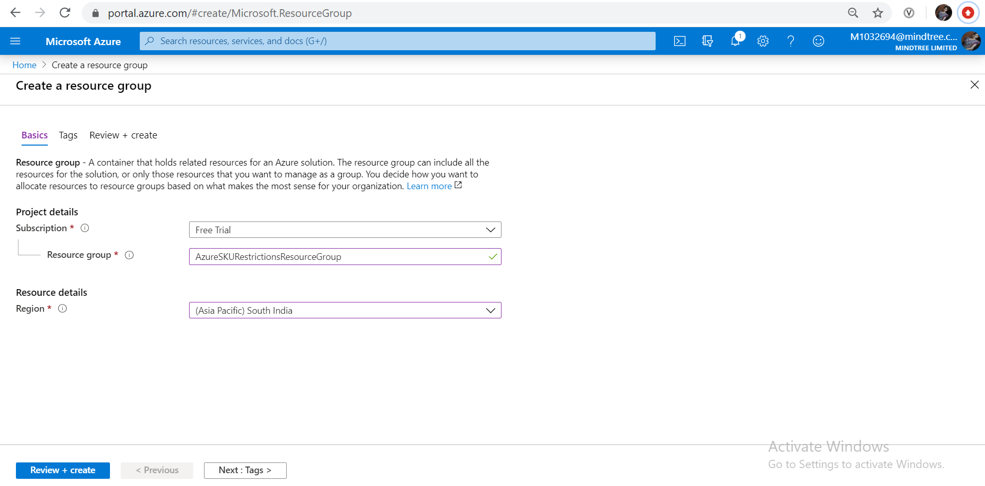

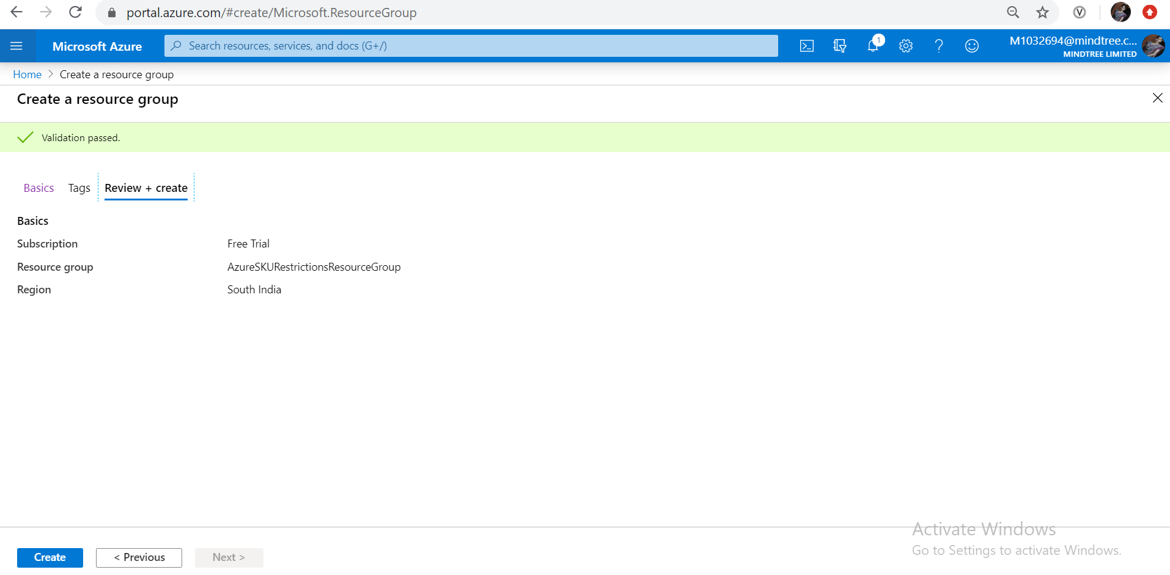

Azure Storage Account creation:

An Azure storage account contains all of your Azure Storage data objects: blobs, files, queues, tables, and disks. ... Data in your Azure storage account is durable and highly available, secure, and massively scalable

I have created the storage account named as “azureskurestrictionstore”, Below screen shots, shows how create resource group.

Go to storage Accounts and click add, then it will take to create storage account as per the below screen shots.

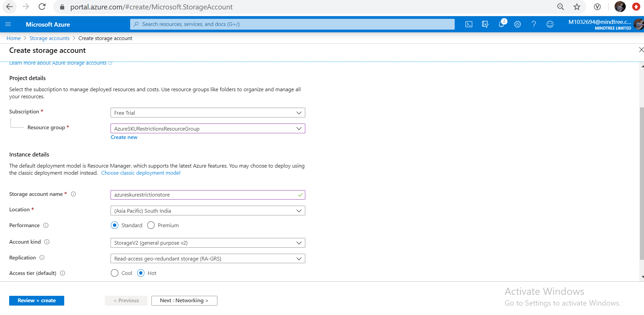

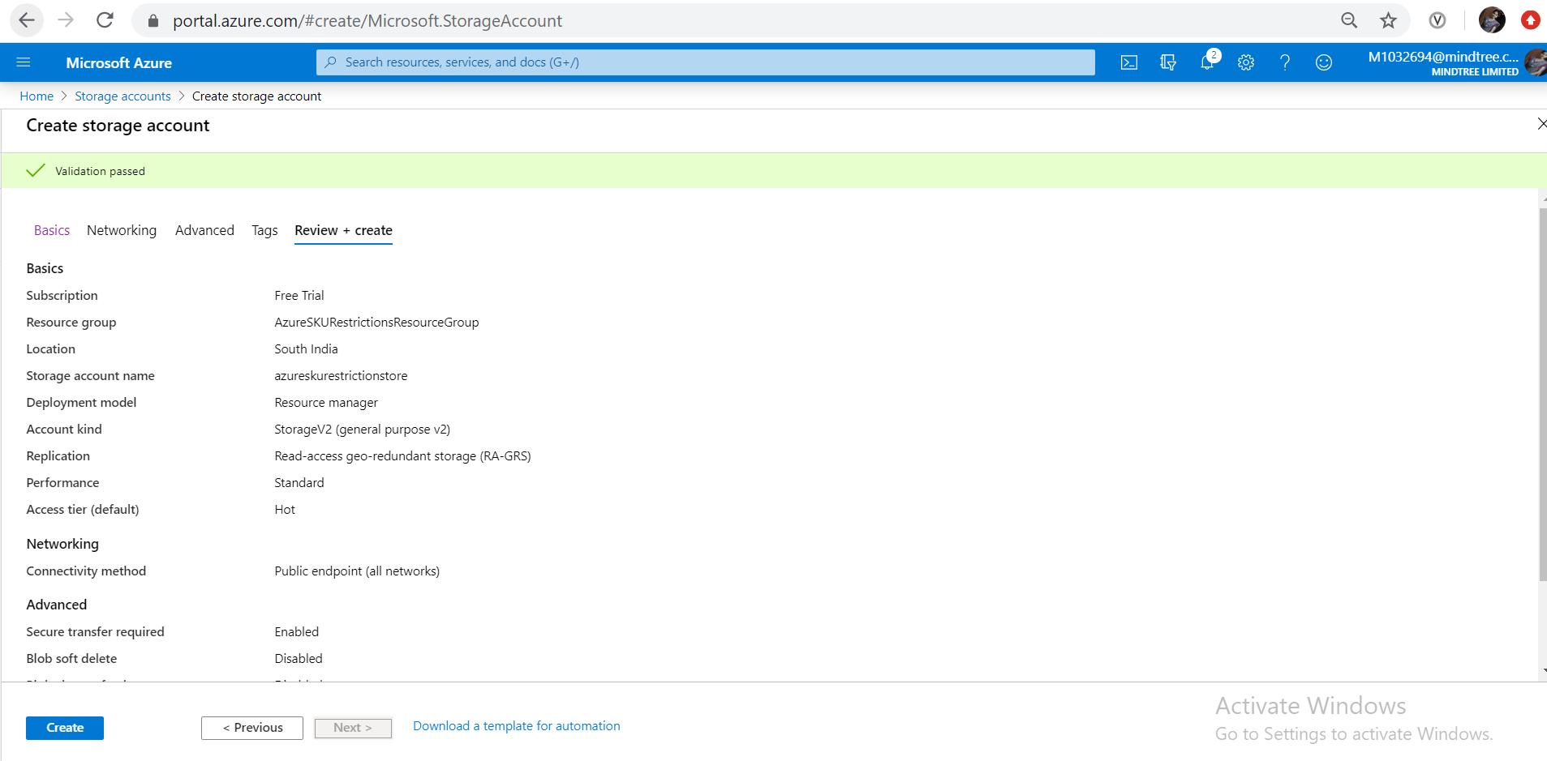

Following is the automation script for the creation of storage account. And it is extracted from the below window(PFB screen shot).

We can download the script and can add it has library for feature use and need to do some changes in script if needed and deploy.



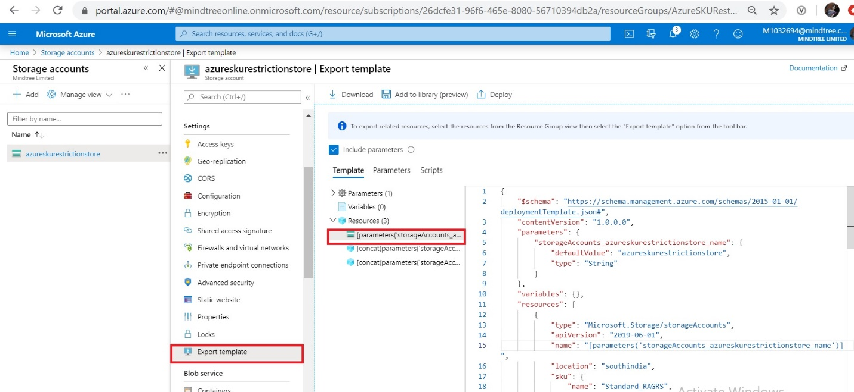

{

"$schema": "https://schema.management.azure.com/schemas/2015-01-01/deploymentTemplate.json#",

"contentVersion": "1.0.0.0",

"parameters": {

"storageAccounts_azureskurestrictionstore_name": {

"defaultValue": "azureskurestrictionstore",

"type": "String"

}

},

"variables": {},

"resources": [

{

"type": "Microsoft.Storage/storageAccounts",

"apiVersion": "2019-06-01",

"name": "[parameters('storageAccounts_azureskurestrictionstore_name')]",

"location": "southindia",

"sku": {

"name": "Standard_RAGRS",

"tier": "Standard"

},

"kind": "StorageV2",

"properties": {

"networkAcls": {

"bypass": "AzureServices",

"virtualNetworkRules": [],

"ipRules": [],

"defaultAction": "Allow"

},

"supportsHttpsTrafficOnly": true,

"encryption": {

"services": {

"file": {

"keyType": "Account",

"enabled": true

},

"blob": {

"keyType": "Account",

"enabled": true

}

},

"keySource": "Microsoft.Storage"

},

"accessTier": "Hot"

}

},

{

"type": "Microsoft.Storage/storageAccounts/blobServices",

"apiVersion": "2019-06-01",

"name": "[concat(parameters('storageAccounts_azureskurestrictionstore_name'), '/default')]",

"dependsOn": [

"[resourceId('Microsoft.Storage/storageAccounts', parameters('storageAccounts_azureskurestrictionstore_name'))]"

],

"sku": {

"name": "Standard_RAGRS",

"tier": "Standard"

},

"properties": {

"cors": {

"corsRules": []

},

"deleteRetentionPolicy": {

"enabled": false

}

}

},

{

"type": "Microsoft.Storage/storageAccounts/fileServices",

"apiVersion": "2019-06-01",

"name": "[concat(parameters('storageAccounts_azureskurestrictionstore_name'), '/default')]",

"dependsOn": [

"[resourceId('Microsoft.Storage/storageAccounts', parameters('storageAccounts_azureskurestrictionstore_name'))]"

],

"sku": {

"name": "Standard_RAGRS",

"tier": "Standard"

},

"properties": {

"cors": {

"corsRules": []

}

}

},

{

"type": "Microsoft.Storage/storageAccounts/blobServices/containers",

"apiVersion": "2019-06-01",

"name": "[concat(parameters('storageAccounts_azureskurestrictionstore_name'), '/default/testcontainer')]",

"dependsOn": [

"[resourceId('Microsoft.Storage/storageAccounts/blobServices', parameters('storageAccounts_azureskurestrictionstore_name'), 'default')]",

"[resourceId('Microsoft.Storage/storageAccounts', parameters('storageAccounts_azureskurestrictionstore_name'))]"

],

"properties": {

"publicAccess": "Container"

}

}

]

}

## Below screenshot the show the over view of storage account “azureskurestrictionstore” Sku restrictions, encryption enabled and allow https access only.

## 

## 

## Blobs are typically images, audio or any multimedia objects, To show we access via https access only I have selected the Blobs services and uploaded the images by creating the container name as “testcontainer”. Below screen shots shows the same

## 

## After creating the container using the upload option we have uploaded the two images

## 

## 

## In the below taken the “orderedlist0.png” path, This blob image path can be accessed via Https as per the configuration. Below screen shots will shows the same

## 

## 